space case
by Stuart Gibbs

Assignment #1

Read the following passage from the book and answer the questions below.
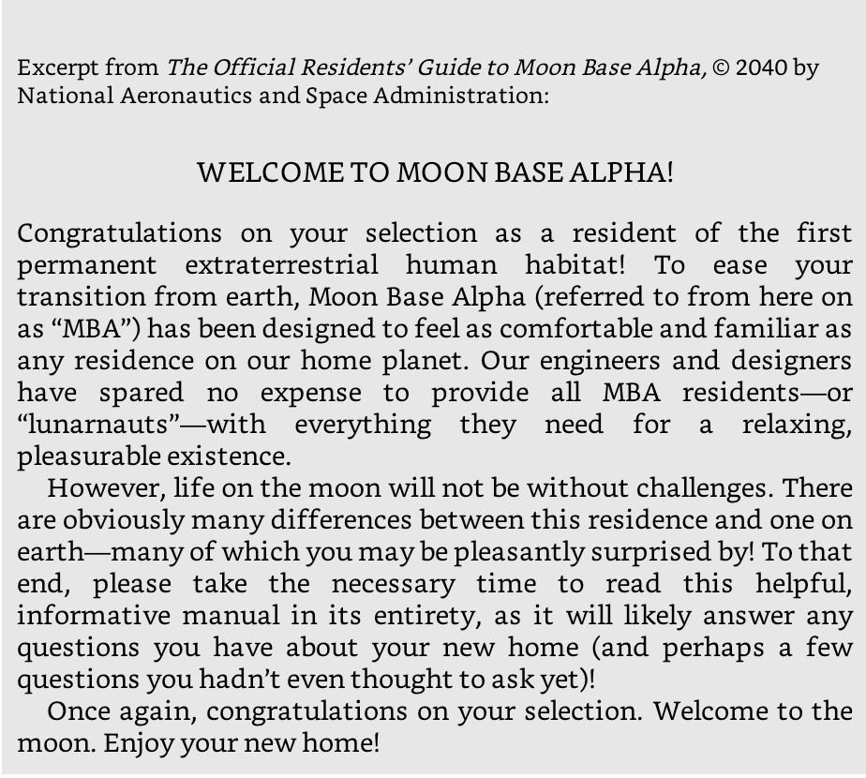

1. Predict what some of the differences between the residence on the moon and a residence on earth would be.

2. How would you feel about living on the moon after reading this section?

