Escape From Mr. Lemoncello’s Library
by Chris Grabenstein

Assignment #14

Below is the Bonus Clue. Use the Rebus Puzzle, to solve the final puzzle.

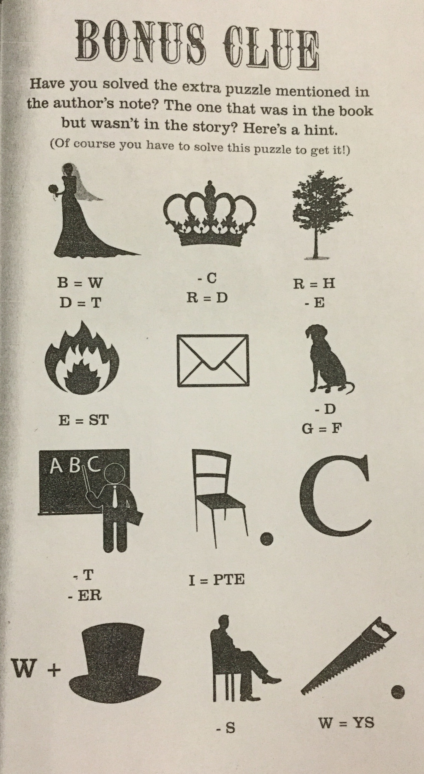

A. Rebus Puzzle Solution

B. Final puzzle solution.

