Every child is gifted.
They just unwrap their packages at different time. ~ unknown

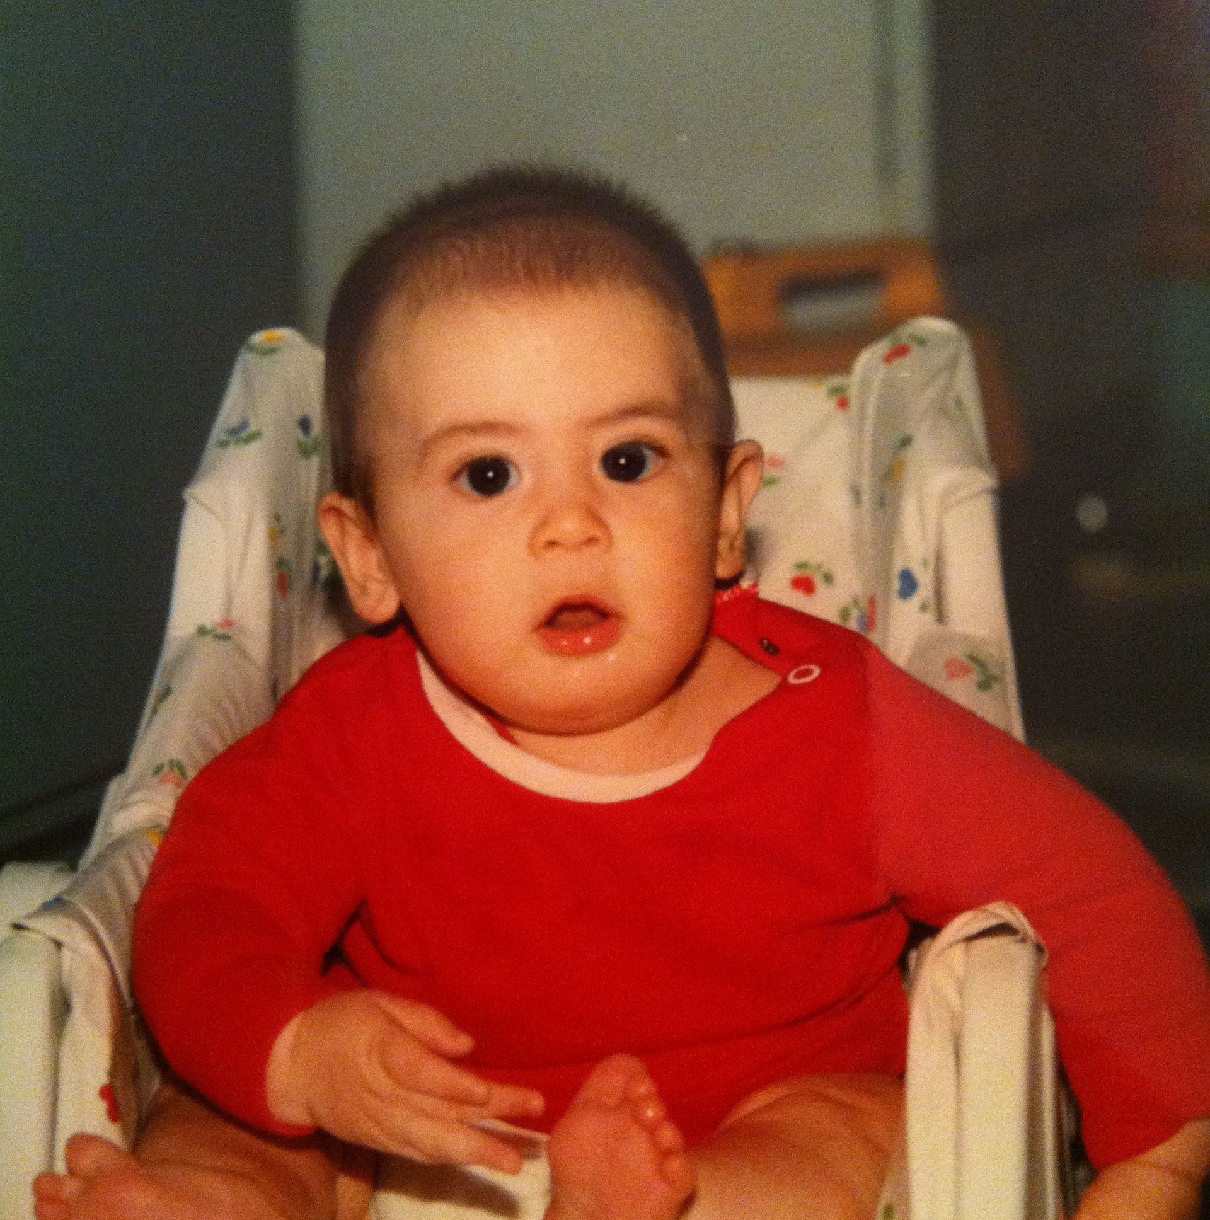

Watch Me Grow

A WebQuest for 8th Grade Family Consumer Science

This lesson is designed to give you an understanding of the way in which children grow: physically, intellectually, emotionally and socially. This understanding will allow you to create and use activities that help promote growth in each of these areas. You can then use these activities in various babysitting situations thus contributing to a successful sitting experience.

The Task

Throughout this webquest, you will need to identify the characteristics of each stage of development for children age birth to 4 years old. You will be required to recommend age appropriate activities that will enhance (P.I.E.S.) physical, intellectual, emotional and social for each particular stage of development.

The Process

This webquest begins with providing you with different babysitting scenarios. Listed below are the different families with children that need you to baby-sit. You must visit each family household to baby-sit and gain field experience to earn your Super Sitter Certificate. As the sitter, you need to identify 3 characteristics of each developmental stage (P.I.E.S.) relating to what the child is capable of doing. You will also need to list two activities that you could provide, to promote this stage of development. You should refer to the information links provided to help you research your answers. You will fill out the webquest worksheet and quiz. You will receive your Super Sitter Certification when everything is completed correctly. Good Luck and remember to enjoy the journey.

P.I.E.S.

1. Physical development deals with a child’s balance and coordination. It also has to do with the use of fine and gross motor skills as the child’s body grows and develops.

2. Intellectual development is sometimes referred to as mental or cognitive development. This is where the child learns to think, reason and understand basic concepts to develop their mind. This is also an important part of the child’s language development.

3. Emotional development means that the child needs to learn how to express their emotions in acceptable ways.

4. Social development means that the child learns to take turns, share and interact with others in appropriate ways.

First Babysitting Assignment: Rosa Family

You are sitting 4-month-old Annie Rosa. What are 3 characteristics relating to a child Annie’s age and what are 2 activities you can do with Annie to help promote this stage of development? Click on the following links to help you with the research.

http://webshare.northseattle.edu/fam180/topics/agestages/growing.htm

http://www.kidsource.com/kidsource/content3/AmericaReads/babies.html

http://www.pbs.org/wholechild/abc/index.html

Second Babysitting Assignment: Donner Family

You have been hired to sit 8-month-old Tyler Donner. Identify 3 characteristics relating to a child Tyler’s age and list 2 activities you can do with Tyler. Click on the following links to help you with the research and write the information in your Super Sitter’s guidebook.

http://webshare.northseattle.edu/fam180/topics/agestages/growing.htm

http://www.pbs.org/wholechild/abc/index.html

Third Babysitting Assignment: McDonald Family

You are caring for little 1-year-old Jimmy McDonald. At Jimmy’s age what are 3 characteristics in his development that are important for you to recognize? What are 2 activities you can do with Jimmy? Click on the following link to help you find your information and write it in your Super Sitter’s guidebook.

http://www.nlm.nih.gov/medlineplus/ency/article/002005.htm

http://www.pbs.org/wholechild/abc/index.html

Fourth Babysitting Assignment: Oliver Family

You will care for 2-year-old Herman. What are 3 characteristics that are important for you to recognize at this age? What are 2 activities you can do with little Herman? Click on the following link to help you find the information and write it in your Super Sitter’s guidebook.

http://www.nlm.nih.gov/medlineplus/ency/article/002012.htm

http://www.cdc.gov/ncbddd/actearly/milestones/milestones-2yr.html

Fifth Babysitting Assignment: Russell Family

You will be responsible to care for little 4-year-old Toby and his friend Gus Burton who is 3 years old. Identify 3 characteristics that are important for you to recognize as you care for these little tykes. What 2 activities could you do with little Toby and Gus? Click on the following link to help find the information and write it in your Super Sitter’s guidebook.

http://www.nlm.nih.gov/medlineplus/ency/article/002015.htm

http://www.cdc.gov/ncbddd/actearly/milestones/milestones-4yr.html

http://www.parentingcounts.org/professionals/parenting-handouts/information-for-parents-play.pdf

http://childdevelopmentinfo.com/child-development/play-work-of-children/pl5/

Step 1: Complete the Webquest and the worksheet and email them to Andrea when you have filled in your answers.

I am 3
I am not built to sit still, keep my hands to myself, take turns, be patient, and stand in line, or keep quiet.
I need motion,
I need novelty,
I need adventure,
And I need to engage the world with my whole body.
LET ME PLAY
(trust me, I’m learning)
~ Unknown

Credits & References

Resources used to create this webquest and lesson can be found in the following websites:

http://www.baptistonline.org/health/library/chil3047.asp

http://www.baptistonline.org/health/library/chil3051.asp

http://www.cdc.gov/ncbddd/actearly/milestones/index.html

http://www.nlm.nih.gov/medlineplus/ency/article/002456.htm

http://www.easd.k12.pa.us/ems/Curriculum/RelatedArts/FCS/Exploring%20the%20Wonder%20Years.pdf

http://childdevelopmentinfo.com/child-development/play-work-of-children/pl5/

http://www.parentingcounts.org/professionals/parenting-handouts/information-for-parents-play.pdf

Modified for Centre Learning Community Charter School
2013

