Name

The Risks of Poor Nutrition

Read the article below from www.cdc.gov then complete the following.

List the benefits of eating healthy

List the consequences of not eating healthy

What eating behaviors do you have that you could improve on?

Childhood Nutrition Facts
Overview
Healthy eating in childhood and adolescence is important for proper growth and development and to prevent various health conditions.^{1,2} The 2015–2020 Dietary Guidelines for AmericansExternal recommend that people aged 2 years or older follow a healthy eating pattern that includes the following²:
- A variety of fruits and vegetables
- Whole grains
- Fat-free and low-fat dairy products
- A variety of protein foods
- Oils
These guidelines also recommend that individuals limit calories from solid fats (major sources of saturated and trans fatty acids) and added sugars, and reduce sodiumintake.² Unfortunately, most children and adolescents do not follow the recommendations set forth in the Dietary Guidelines for Americans.^{2–4}
Benefits of Healthy Eating
Healthy eating can help individuals achieve and maintain a healthy body weight, consume important nutrients, and reduce the risk of developing health conditions such as^{1,2}
- High blood pressure
- Heart disease
- Diabetes
- Cancer
- Osteoporosis
- Iron deficiency
- Dental caries (cavities)
Consequences of a Poor Diet
- A poor diet can lead to energy imbalance (e.g., eating more calories than your body uses) and can increase the risk of becoming overweight or obese.^{1,5}
- A poor diet can increase the risk for lung, esophageal, stomach, colorectal, and prostate cancers.^{2,6}
- Hunger and food insecurity (i.e., reduced food intake and disrupted eating patterns due to a lack of household income and other resources for food) might increase the risk for lower dietary quality and undernutrition. In turn, undernutrition can negatively affect overall health, cognitive development, and school performance.^{7–9}
Tips for Healthy Eating
- The US Department of Agriculture provides
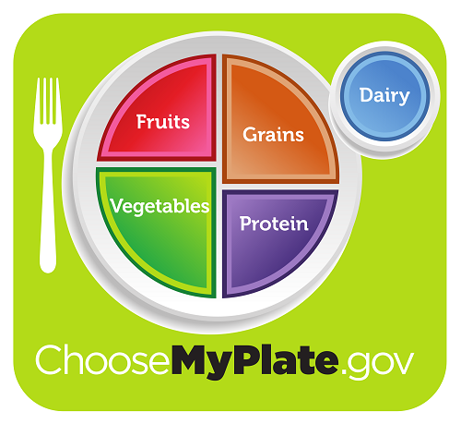
Diet and Academic Performance
- Schools are in a unique position to provide students with opportunities to learn about and practice healthy eating behaviors.¹⁵
- Eating a healthy breakfast is associated with improved cognitive function (especially memory), reduced absenteeism, and improved mood.^{16–18}
- Adequate hydration may also improve cognitive function in children and adolescents, which is important for learning.^{19–23}
Eating Behaviors of Young People
- Between 2001 and 2010, consumption of sugar-sweetened beverages among children and adolescents decreased, but still accounts for 10% of total caloric intake.¹⁰
- Between 2003 and 2010, total fruit intake and whole fruit intake among children and adolescents increased. However, most youth still do not meet fruit and vegetable recommendations.^{11,12}
- Empty calories from added sugars and solid fats contribute to 40% of daily calories for children and adolescents age 2–18 years—affecting the overall quality of their diets. Approximately half of these empty calories come from six sources: soda, fruit drinks, dairy desserts, grain desserts, pizza, and whole milk.⁴ Most youth do not consume the recommended amount of total water.¹³

